**PRESS RELEASE**

**No. 57/SP/TKP-ASEAN2023/04/2023**

**PUBLIC COMMUNICATIONS TEAM**

**President Joko Widodo Inspects Puncak Waringin Readiness for ASEAN Summit**

**Jakarta, Kominfo Newsroom** – President of the Republic of Indonesia, Joko Widodo, checked the readiness of Puncak Waringin, Labuan Bajo, West Manggarai, East Nusa Tenggara (NTT), as one of the locations for the ASEAN Summit scheduled on 9-11 May 2023.

“Yes, (inspecting the readiness) for the Spouse Program,” said the President Director of the Labuan Bajo and Flores Tourism Authority, Shana Fatina, in Labuan Bajo on Tuesday (25 April).

President Joko Widodo, First Lady Iriana, and their grandson, Jan Ethes, arrived at Puncak Waringin, Labuan Bajo, at 10.08 WITA (Central Indonesian Time).

The head of state was accompanied by Foreign Affairs Minister, Retno Marsudi, NTT Governor, Viktor Bungtilu Laiskodat, and his wife, Julie Sutrisno Laiskodat.

The president wore a white shirt while First Lady Iriana wore a blue dress. Their grandson wore a white T-shirt.

The president’s entourage entered the Puncak Waringin area under a tight escort by the Presidential Guard (Paspampres).

Puncak Waringin is the venue for the ASEAN Summit’s Spouse Program, which is an activity for the spouses of ASEAN heads of state who will attend the summit.

After spending about 48 minutes at Puncak Waringin, President Joko Widodo, and his entourage left the area at 10:48 WITA.

After departing from Puncak Waringin, President Joko Widodo continued his agenda and is scheduled to return to Jakarta on Tuesday afternoon.

President Joko Widodo has also inspected other locations that will be used for the ASEAN Summit in Labuan Bajo, East Nusa Tenggara.

The president arrived in Labuan Bajo on Saturday evening (22 April). In addition to inspecting the locations, the head of state took his family on a vacation. President Joko Widodo visited Loh Buaya, Rinca Island, Komodo National Park, on Monday (24 April).

The head of state also visited Loh Buaya to ensure that the tourist spot can be visited comfortably by delegates during the 42nd ASEAN Summit.

During his visit to Loh Buaya, Joko Widodo passed through the elevated deck that was completed in 2022.

The president also took a short break at Café Ranger before heading to the Komodo Information Center to see the 52 dioramas. (Fransisca/TR/Elvira)

***

For more information, please contact:

**Director General of Public Information and Communications of the Ministry of Communications and Informatics – Usman Kansong (0816785320).**

Get other information at <https://infopublik.id>

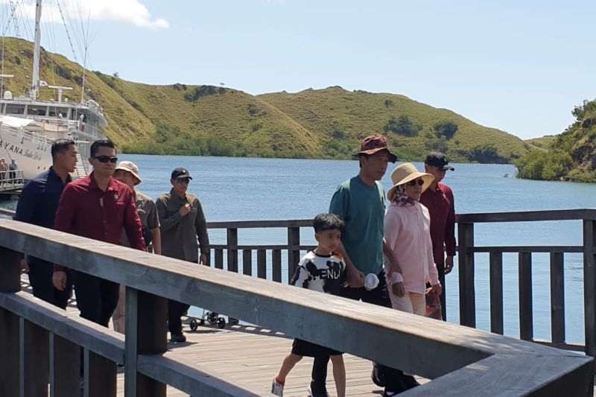

President Joko Widodo and his family visit Loh Buaya, Rinca Island, Komodo National Park, West Manggarai, East Nusa Tenggara (NTT), on Monday (24 April 2023). ANTRA TO/HO-Personal Documentation